Chapter 10, Problem 25.

Solve for i_{o} in Fig. 10.73 using mesh analysis.

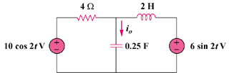

Figure 10.73
For Prob. 10.25.

